Pandit Deendayal Energy University

# Department of Computer Science & Engineering

Web Technology Assignment-8 (23CP206P)



# Name: Ravi Jamanbhai Makwana

Roll No: **21BCP418**

Division: **6**

Group: **12**

Branch: **CSE 2025**

**Practical: 8**

**Aim:** Implement the web applications using JSP.

**Requirement:** Laptop /Computer

## Software Requirement: -

- Windows 10/11 / Browser (Chrome, Brave, Firefox) / Winget

- JSP / XAMPP / VS code / Notepad

**Knowledge Requirement:** HTML, CSS, JSP

**page.jsp**

<html>

<head>

<title>JSP-1</title>

</head>

<body>

<% double num=Math.random(); if (num> 0.95) { %>

<h2>You'll have a luck day!</h2>

<p>(<%= num %>)</p>

<% } else { %>

<h2>Well, life goes on ...</h2>

<p>(<%= num %>)</p>

<% } %>

<a href="<%= request.getRequestURI() %>">

<h3>Try Again</h3>

</a>

</body>

</html>

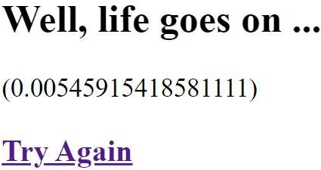

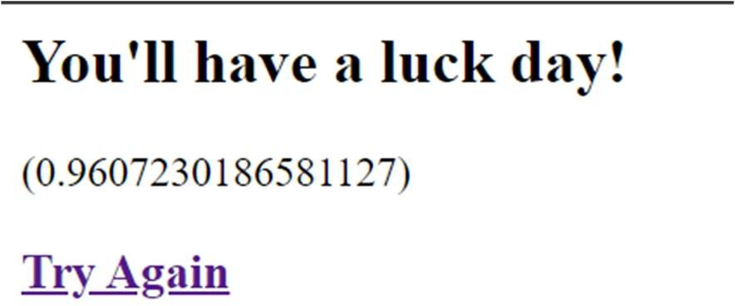

## Index.html

<meta charset="ISO-8859-1" />

<title>This page will send a request to a Java JSP Page.</title>

<a> This page will <b>send a request</b> to a <b>Java JSP Page</b>. </a>

<p style="margin-top: 0; margin-bottom: 0"></p>

<form action="login.jsp">

Name: <input type="text" name="name" />

<br />

Telephone#: <input type="text" name="telephone" />

<input type="submit" value="Submit" />

</form>

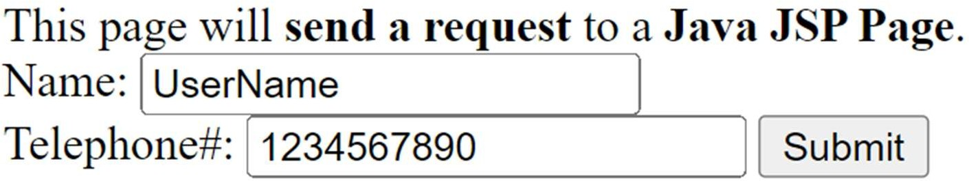

## Login.jsp

<title>This is a Java JSP Page - Example</title>

<b><big>This is a Java JSP Page - Example</big></b>

<br>

This is a clasic HTML content into a JSP Page !

<br><br>

From the index.html I have received into JSP Page the <b>name</b> parameter. Name =

<%= request.getParameter("name") %>

<br>

From the index.html I have received into JSP Page the <b>telephone</b> parameter. Telephone# =

<%= request.getParameter("telephone") %>

